Project Report   
Contents

1 Abstract

2 Introduction

3. Literature Survey

- Related Work

- Requirement Analysis

- Requisite

- System Architecture

- Functional Requirements

- Non - Functional Requirements

4 System Analysis and Design

Types of SDLC model Used

UML diagrams

5. System Implementation

In detail + snapshots + coding

7 Conclusion

Future scope + conclusion

8 References

**Abstract**

The increasing interest in botany, horticulture, and environmental conservation has led to a surge in demand for efficient plant identification tools. This project presents a Progressive Web Application (PWA) designed to facilitate accurate and swift identification of plants through image uploads. Leveraging modern web technologies, this application not only offers a user-friendly interface but also provides offline capabilities and an engaging user experience, aligning with the current trends in mobile application development.

The core functionality of the application is based on an advanced image recognition API that processes user-uploaded images of plants to identify their species. Users can select and upload images from their devices, and the application communicates with the identification API to fetch relevant results. This is achieved through a well-structured RESTful API, which handles the image processing and returns detailed information, including scientific names, common names, and identification scores. The application currently supports various image formats (JPEG and PNG) and provides immediate feedback to the user, enhancing the overall experience.

The user interface is designed with a modern aesthetic, utilizing a green and white color palette that resonates with the theme of nature. The layout is responsive and visually appealing, featuring animations and hover effects that improve usability and engagement. A central feature of the application is its navigation bar, which allows users to easily access different functionalities, including image uploads and results viewing. Moreover, a significant aspect of the user experience is the preview of selected images, displayed alongside the upload form to provide immediate visual feedback.

One of the standout features of this project is its implementation as a PWA. By utilizing service workers, the application can function offline, allowing users to upload images and receive identification results without requiring a continuous internet connection. This capability is particularly beneficial for users in remote areas or for those who wish to identify plants during outdoor activities. The application also includes a manifest file that enables installation on various devices, providing users with an app-like experience directly from their web browsers.

Additionally, the project emphasizes accessibility and responsiveness, ensuring that users on various devices—whether smartphones, tablets, or desktop computers—can seamlessly interact with the application. This approach not only caters to a wider audience but also aligns with the modern expectations of web applications.

In conclusion, this plant identification Progressive Web Application combines cutting-edge technology with an intuitive user interface to deliver a practical tool for nature enthusiasts, students, and professionals alike. By integrating plant identification capabilities with a stylish and engaging design, the application serves as an exemplary project that showcases the potential of PWAs in delivering rich user experiences. As the application continues to evolve, further enhancements may include expanded database support for more species, improved algorithms for faster identification, and additional features tailored to user feedback. This project ultimately demonstrates the intersection of technology and nature, fostering a greater appreciation for biodiversity and environmental awareness.

1. **Introduction**

In recent years, the intersection of technology and environmental science has become increasingly prominent as the world faces urgent environmental challenges. Rapid urbanization, climate change, and loss of biodiversity have raised awareness about the importance of preserving our planet's natural resources. In this context, understanding and identifying plant species has become crucial for researchers, environmentalists, and the general public. One significant challenge in botany is accurately identifying plant species. Traditional methods often rely on extensive knowledge, printed guides, or expert consultation, which can be inaccessible for many individuals. This gap highlights the need for innovative solutions that leverage technology to simplify the process of plant identification.

**Problem Statement**

The ability to identify plants accurately is essential for various stakeholders, including botanists, horticulturists, ecologists, and everyday nature enthusiasts. The current methods of identification, such as consulting field guides or relying on expert opinion, can be time-consuming and sometimes inadequate. This inefficiency often results in misidentifications, which can have significant consequences, particularly in fields like agriculture, conservation, and landscaping. For instance, identifying invasive species is vital for maintaining ecosystem balance and biodiversity. However, many individuals lack the knowledge required to distinguish between native and invasive plants.

Moreover, the rapid changes in the environment due to climate change can alter the appearance of certain plant species, further complicating identification. This is particularly concerning as many ecosystems are under threat from invasive species, habitat loss, and changing climate conditions. Furthermore, in our fast-paced society, individuals seek immediate solutions and quick access to information. Traditional identification methods do not meet the demands of today’s technology-driven world, underscoring the need for a solution that is not only efficient but also user-friendly and accessible.

**Proposed Solution**

To address these challenges, we propose the development of a Progressive Web Application (PWA) dedicated to plant identification. This application will harness advanced image recognition technology to allow users to identify plants quickly and accurately. By enabling users to upload an image of a plant, the application will analyze the photo and provide immediate identification results, including the plant’s common and scientific names, as well as relevant characteristics.

The PWA aims to create an intuitive and engaging user experience, allowing users of all backgrounds to access vital information about plant species. By leveraging a sophisticated image recognition API, the application will deliver accurate results while providing a seamless interface. Users can simply take a photo of a plant using their smartphone or tablet, upload it through the application, and receive instant feedback. This functionality not only democratizes access to botanical knowledge but also empowers individuals to engage with their environment actively.

In addition to image recognition capabilities, the PWA will incorporate offline functionalities, ensuring that users can access the application and perform plant identification without a stable internet connection. This feature is particularly beneficial for outdoor activities like hiking or field research, where internet access may be limited or unavailable. By making plant identification accessible in remote areas, the application can foster a deeper connection with nature and encourage users to explore their surroundings.

**Technological Framework**

The development of this plant identification PWA is grounded in a robust technological framework that enhances functionality, usability, and performance. The primary components of the technology stack include:

1. **Frontend Development:** The user interface will be crafted using HTML, CSS, and JavaScript, offering a responsive and interactive experience. The design will prioritize accessibility and usability, ensuring that users can navigate the application effortlessly. Frameworks like Bootstrap will be utilized to create responsive layouts and animations, resulting in a visually appealing environment. The goal is to ensure that users feel comfortable and engaged while using the application, regardless of their technological proficiency.
2. **Backend Development:** The backend of the application will utilize Node.js and Express.js to handle requests and manage communication between the frontend and the image recognition API. This server-side framework allows for efficient processing of user inputs and facilitates the retrieval of identification results from the API. The architecture will be designed to ensure scalability, allowing the application to handle a growing number of users and requests as it gains popularity.
3. **Image Recognition API:** The core functionality of the application will be powered by a sophisticated image recognition API that processes user-uploaded images to identify plant species. This API employs advanced machine learning algorithms to analyze the images and return accurate results based on the characteristics of the plants. By continuously updating its database with new species and information, the API can provide users with reliable and relevant results, thereby enhancing the overall user experience.
4. **Progressive Web App Features:** By implementing service workers and a manifest file, the application will be transformed into a PWA. This transformation allows users to install the application on their devices and access it offline. PWAs combine the best features of web and mobile applications, enabling users to enjoy a native-like experience without needing to download an app from an app store. This approach not only simplifies the user experience but also increases the application’s accessibility.

**Significance of the Project**

The development of the plant identification PWA carries significant implications for various stakeholders. For researchers and educators, the application serves as a valuable resource for field studies and data collection, enabling them to identify species quickly and efficiently. By providing instant access to plant identification, educators can enhance their teaching methods, allowing students to engage with botanical concepts more effectively. Furthermore, the application can be integrated into curriculum activities, facilitating hands-on learning experiences for students.

For environmentalists and conservationists, the application can contribute to biodiversity monitoring and conservation efforts. By empowering individuals to identify and report plant species, particularly invasive species, the application plays a role in promoting environmental awareness and stewardship. Users can share their findings with local conservation organizations, contributing to collective efforts aimed at preserving native ecosystems.

The PWA can also benefit gardening enthusiasts and landscape architects, providing them with essential information about plants and their care requirements. Whether selecting plants for a garden or designing landscapes, users can make informed decisions that promote sustainability and biodiversity. This tool can serve as a guide for individuals seeking to create native gardens, thus contributing to local ecological health.

**User-Friendliness and Accessibility**

One of the standout features of the plant identification PWA is its emphasis on user-friendliness and accessibility. The application is designed to cater to users of all backgrounds, from experienced botanists to casual nature lovers. With an intuitive interface, users can easily navigate through the process of uploading images and accessing identification results without requiring technical expertise. The design will prioritize clarity and simplicity, ensuring that users can quickly understand how to use the application and find the information they need.

Additionally, the application’s responsiveness ensures that it is accessible on various devices, including smartphones, tablets, and desktop computers. Given the widespread use of mobile devices, particularly among younger generations, developing a PWA aligns with contemporary user preferences and habits. This accessibility is crucial for reaching a broad audience and encouraging widespread engagement with the application.

The plant identification Progressive Web Application represents a significant advancement in the realm of botanical studies and environmental conservation. By addressing the challenges of traditional plant identification methods, the application offers a modern, efficient, and accessible solution that meets the needs of a diverse user base. Through the integration of cutting-edge technology and a commitment to user experience, this project not only aims to enhance plant identification but also fosters a greater appreciation for biodiversity and the natural world. As the application evolves, it has the potential to serve as a comprehensive tool for environmental education, conservation efforts, and the promotion of sustainable practices. By empowering individuals to identify and understand the plants around them, we take a crucial step toward a more informed and environmentally conscious society.

1. **Literature Survey**

The increasing need for environmental awareness and conservation has led to a surge in technological advancements in plant identification tools. Such tools serve various purposes, from aiding in educational contexts to enhancing biodiversity conservation efforts. This literature survey delves into existing methodologies, tools, and applications, analyzing their strengths and weaknesses to inform the design and development of our Progressive Web Application (PWA) for plant identification.

**Existing Plant Identification Applications**

1. **PlantSnap**
   * **Overview**: Launched in 2017, PlantSnap has become a popular mobile application that allows users to identify plants by simply taking a photo. With a database containing millions of plant species, PlantSnap utilizes advanced image recognition algorithms to compare user images against its extensive library.
   * **Strengths**:
     + **User-Friendly Interface**: The application is designed for ease of use, allowing users of all ages to engage with the technology effortlessly.
     + **Large Database**: Its comprehensive plant database significantly increases the likelihood of accurate identifications.
   * **Limitations**:
     + **Subscription Model**: While the app is free to download, many of its features are locked behind a paywall, which may deter users from accessing essential functionalities.
     + **Limited Educational Resources**: Although it provides identification, PlantSnap lacks in-depth educational content that could benefit users looking to learn more about the identified species.
2. **iNaturalist**
   * **Overview**: A collaborative project developed by the California Academy of Sciences and the National Geographic Society, iNaturalist allows users to share observations of plants and animals while providing identification assistance through community engagement and AI.
   * **Strengths**:
     + **Community Involvement**: The platform fosters a sense of community, allowing users to interact with experts and fellow enthusiasts to improve identification accuracy.
     + **Data Collection for Research**: Observations made by users contribute to biodiversity databases, aiding scientific research and conservation efforts.
   * **Limitations**:
     + **Reliance on Community Input**: While community engagement is a strength, it can also lead to inconsistencies in identification, especially if fewer experts are available to review submissions.
     + **User Experience**: Some users may find the app's interface less intuitive compared to more straightforward identification apps, which could affect usability.
3. **PictureThis**
   * **Overview**: PictureThis is another notable application that uses artificial intelligence to identify plants based on uploaded photos. It not only provides identification results but also offers care tips for users.
   * **Strengths**:
     + **Care Guides**: The app includes valuable care information for identified plants, which enhances user engagement and learning.
     + **High Accuracy**: Leveraging deep learning, PictureThis achieves high accuracy in plant identification.
   * **Limitations**:
     + **Limited Free Features**: Similar to PlantSnap, PictureThis operates on a freemium model, limiting functionality without a paid subscription.
     + **Privacy Concerns**: Users must consent to data collection, raising potential privacy issues that could deter some from using the app.
4. **Google Lens**
   * **Overview**: Google Lens is a versatile image recognition tool that can identify not only plants but also a wide range of objects. By using Google's extensive AI capabilities, it provides users with real-time information based on their photos.
   * **Strengths**:
     + **Multi-Purpose Functionality**: Beyond plant identification, Google Lens can recognize objects, translate text, and even scan barcodes, making it a multifunctional tool.
     + **Integration with Google Services**: Users can easily access additional information about plants through Google Search, enhancing their learning experience.
   * **Limitations**:
     + **Generalization**: While effective for many common plants, its accuracy may drop with less common species due to a lack of focused training on specific botanical data.
     + **Requires Internet Connection**: For full functionality, users need to be connected to the internet, which can limit usability in remote areas.

**Challenges in Existing Solutions**

The existing plant identification applications showcase significant advancements in technology and user engagement; however, they also highlight common challenges:

* **Accessibility**: Many applications require subscriptions or in-app purchases, limiting access for users who cannot afford these fees. This exclusion can hinder educational efforts, particularly in regions where biodiversity knowledge is crucial for environmental conservation.
* **User Experience**: Applications that rely heavily on community engagement may result in variable accuracy and a disjointed user experience. New users may struggle to navigate platforms that do not prioritize straightforward identification processes.
* **Privacy and Data Security**: With increasing awareness of data privacy, many users are concerned about how their data is collected and used. Applications that do not provide transparent privacy policies risk losing user trust.
* **Limited Educational Resources**: While some applications provide identification, they often lack educational materials that could enhance user understanding of plant biology, ecology, and conservation.

**Project Contribution**

Our plant identification PWA aims to address these challenges by providing a free, user-friendly platform that offers accurate plant identification, educational resources, and offline capabilities. By leveraging advanced image recognition technology, we strive to create a tool that is accessible to a broad audience while promoting environmental awareness and education.

**Requirement Analysis**

Requirement analysis is essential for ensuring that the application meets user needs and expectations. This section outlines the requisite for the plant identification PWA, its system architecture, and the functional and non-functional requirements that guide its development.

**Requisite**

The primary requisite for the plant identification PWA is to provide an efficient and accurate tool for identifying plant species through image uploads. The application is designed to serve a diverse user base, including students, environmentalists, and nature enthusiasts, offering a seamless experience in identifying plants without requiring extensive botanical knowledge.

**System Architecture**

The system architecture for the plant identification PWA consists of three primary components:

1. **Frontend**:
   * **User Interface (UI)**: The UI is designed to be intuitive and responsive, facilitating easy navigation and interaction. Users can upload images, view identification results, and access educational materials seamlessly. Built using modern web technologies such as HTML, CSS, and JavaScript, the frontend focuses on providing a clean and engaging experience.
   * **Framework**: A frontend framework (e.g., React, Vue.js) can be utilized to enhance the user experience through component-based architecture, allowing for efficient updates and better state management.
2. **Backend**:
   * **Server-side Logic**: Built using Node.js and Express.js, the backend component manages requests from the frontend, processes image uploads, and communicates with the image recognition API to fetch identification results. It acts as an intermediary, ensuring smooth interaction between the frontend and external services.
   * **Database Management**: A database (e.g., MongoDB, MySQL) can be employed to store user data, identification history, and educational resources, enabling personalized experiences and user engagement.
3. **Image Recognition API**:
   * **API Integration**: The application integrates a third-party image recognition API that analyzes uploaded images and returns relevant plant identification data. This component is crucial for delivering accurate results based on user inputs. The choice of API should be based on its accuracy, speed, and data privacy policies.

**Functional Requirements**

Functional requirements outline the specific features and capabilities of the plant identification PWA:

1. **Image Upload**:
   * Users should be able to upload images of plants in various formats (JPEG, PNG) for identification. The application must handle multiple image uploads, allowing users to compare different plants.
2. **Identification Results**:
   * The application must provide users with the common name, scientific name, and score of the identified plant based on the API’s analysis. Results should be displayed clearly and concisely, with options to learn more about each species.
3. **User Authentication**:
   * Users should have the option to create accounts for personalized experiences, allowing them to save identified plants, view their history, and receive tailored content based on their interests.
4. **Offline Functionality**:
   * The PWA should allow users to access certain features without an internet connection, enabling plant identification in remote areas. Offline caching of previously identified plants and educational content should be implemented.
5. **Educational Resources**:
   * The application should provide educational materials related to identified plants, including care tips, habitat information, and conservation status. This feature will enhance user engagement and promote environmental awareness.
6. **User Feedback**:
   * Users should be able to provide feedback on identification accuracy and share their experiences. This feedback loop can help improve the application and build a community of engaged users.

**Non-Functional Requirements**

Non-functional requirements address the quality attributes of the system and how it performs under various conditions:

1. **Performance**:
   * The application should respond to user requests within a reasonable time frame, ensuring a seamless experience during image uploads and result retrieval. The target response time for image processing should be under five seconds for optimal user satisfaction.
2. **Scalability**:
   * The architecture must be designed to handle an increasing number of users and requests without degradation in performance. Utilizing cloud services for hosting and storage can aid in achieving scalability.
3. **Usability**:
   * The PWA should be easy to use for individuals with varying levels of technological expertise. An emphasis on user-centered design principles will ensure that users can navigate through the application with minimal confusion.
4. **Accessibility**:
   * The application must adhere to accessibility standards, ensuring that users with disabilities can effectively interact with the platform. This includes implementing keyboard navigation, screen reader compatibility, and color contrast guidelines.
5. **Security**:
   * User data, particularly authentication information, must be securely stored and transmitted to prevent unauthorized access. Implementing encryption protocols and regular security audits will enhance the application's security posture.
6. **Cross-Platform Compatibility**:
   * The application should function consistently across different devices and browsers, ensuring a smooth user experience regardless of the platform being used.

The literature survey highlights the advancements and challenges in existing plant identification tools, illustrating the need for an accessible, user-friendly application. Our PWA aims to address these challenges while providing accurate identification and valuable educational resources. The requirement analysis outlines the essential features and architectural components necessary for developing a successful plant identification tool, setting a solid foundation for the subsequent development stages.

By focusing on user needs and addressing common shortcomings in existing applications, this project seeks to create an innovative and engaging platform that fosters environmental awareness and knowledge.

1. **System Analysis and Design**

System Analysis and Design is a critical phase in software development that focuses on understanding user requirements, specifying system functions, and planning the architecture and design of the software solution. This section details the analysis and design process for the plant identification PWA, discussing the selected SDLC model, key components of the system architecture, and the UML diagrams that help visualize the system design.

**Types of SDLC Model Used**

The choice of Software Development Life Cycle (SDLC) model significantly impacts the project's success by guiding the development process. For the plant identification PWA, the **Agile SDLC model** has been selected due to its flexibility and iterative nature. Below are the key characteristics and advantages of using the Agile model:

1. **Iterative Development**:
   * Agile promotes iterative cycles of development, enabling the team to build functional increments of the application in short time frames (sprints). This allows for frequent reassessment and adjustments based on user feedback.
2. **User-Centric Approach**:
   * The Agile model emphasizes active user involvement throughout the development process. Regular feedback from users ensures that the final product aligns with their needs and expectations, leading to higher user satisfaction.
3. **Rapid Prototyping**:
   * The model allows for rapid prototyping, enabling the development team to create functional prototypes quickly. This facilitates early identification of issues and ensures the project stays aligned with user requirements.
4. **Flexibility and Adaptability**:
   * Agile methodologies are designed to accommodate changes in requirements, allowing the development team to adapt to evolving user needs or market demands without significant disruptions.
5. **Continuous Integration and Testing**:
   * Agile promotes continuous integration, where new code is regularly merged with the main codebase and tested. This approach helps detect and resolve issues early, ensuring a more stable application.

The Agile model's focus on collaboration, user feedback, and adaptability makes it an ideal choice for developing the plant identification PWA, where user requirements may evolve as the project progresses.

**System Architecture**

The system architecture outlines the structure and organization of the plant identification PWA, detailing the components and their interactions. The architecture can be divided into three main layers:

1. **Presentation Layer (Frontend)**:
   * This layer represents the user interface of the PWA, designed to be intuitive and user-friendly. It allows users to upload plant images, view identification results, and access educational resources.
   * Technologies used: HTML, CSS, JavaScript, and a frontend framework (e.g., React.js or Vue.js).
2. **Business Logic Layer (Backend)**:
   * The backend layer manages the application's core functionality, including image processing, database management, and interaction with external APIs for plant identification.
   * Technologies used: Node.js, Express.js, and a database system (e.g., MongoDB or MySQL).
3. **Data Layer**:
   * This layer consists of the database that stores user data, identification history, and educational materials. The data layer is crucial for providing a personalized user experience and managing user interactions with the application.

The architecture promotes a clear separation of concerns, enabling easier maintenance and scalability. Each layer can be developed and tested independently, streamlining the development process.

**Use case Diagram**

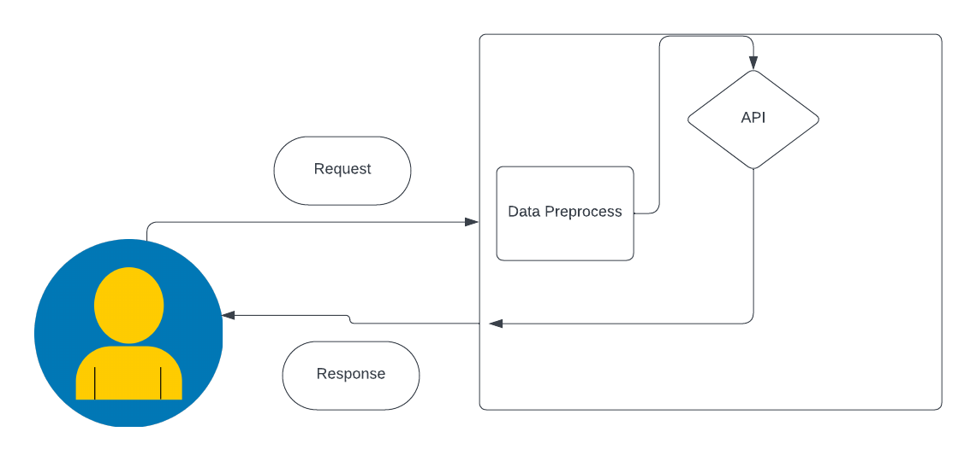

1. **System Implementation**

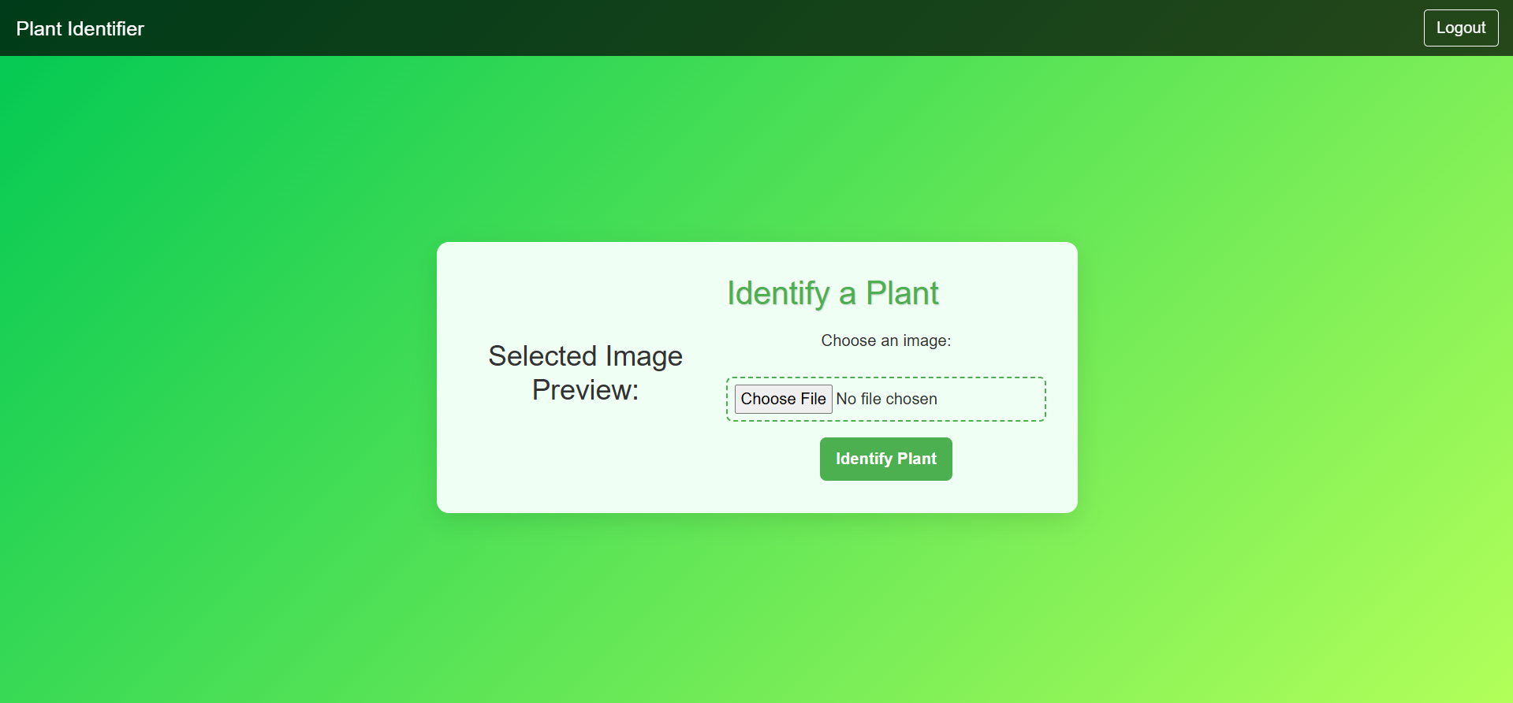

The homepage of this Plant Identification application provides a welcoming and user-friendly interface for users to identify plants through uploaded images. Using a sleek, responsive design and a calming green color palette, the interface emphasizes ease of navigation. The navbar offers quick access to logout functionality, enhancing security for individual user sessions. A prominent "Identify a Plant" form allows users to upload a photo of a plant, preview the selected image, and submit it for identification. The file upload area is visually emphasized with subtle animations, making it interactive and engaging. Built with Bootstrap and animated styling, the homepage not only ensures an aesthetic appeal but also quick accessibility,A screenshot of a plant

The result page of the Plant Identification application is designed to deliver the plant identification findings in a clean, structured, and visually appealing format. After the user submits an image for analysis, the application displays the plant’s essential information, focusing on the common names, scientific name, and identification score. This page is styled with the same modern green and white color palette, keeping the experience cohesive with the rest of the application.

A clear, large header introduces the identification result, while the data is presented in well-organized, card-like containers. Each card includes:

* **Common Names** – Popular names for the plant.
* **Scientific Name** – Official botanical nomenclature.
* **Identification Score** – A confidence score indicating the accuracy of the match.

The layout is designed to highlight the plant's identity visually and informatively, with attention given to readability and elegance. Smooth animations reveal the results, enhancing the experience by making the data appear interactively. Below the details, a “Go Back” button allows users to return to the homepage to identify another plant, maintaining smooth user flow within the app. This page structure is optimized to provide users with precise results that are easy to understand, enhancing the overall usability and educational value of the plant identification experience.

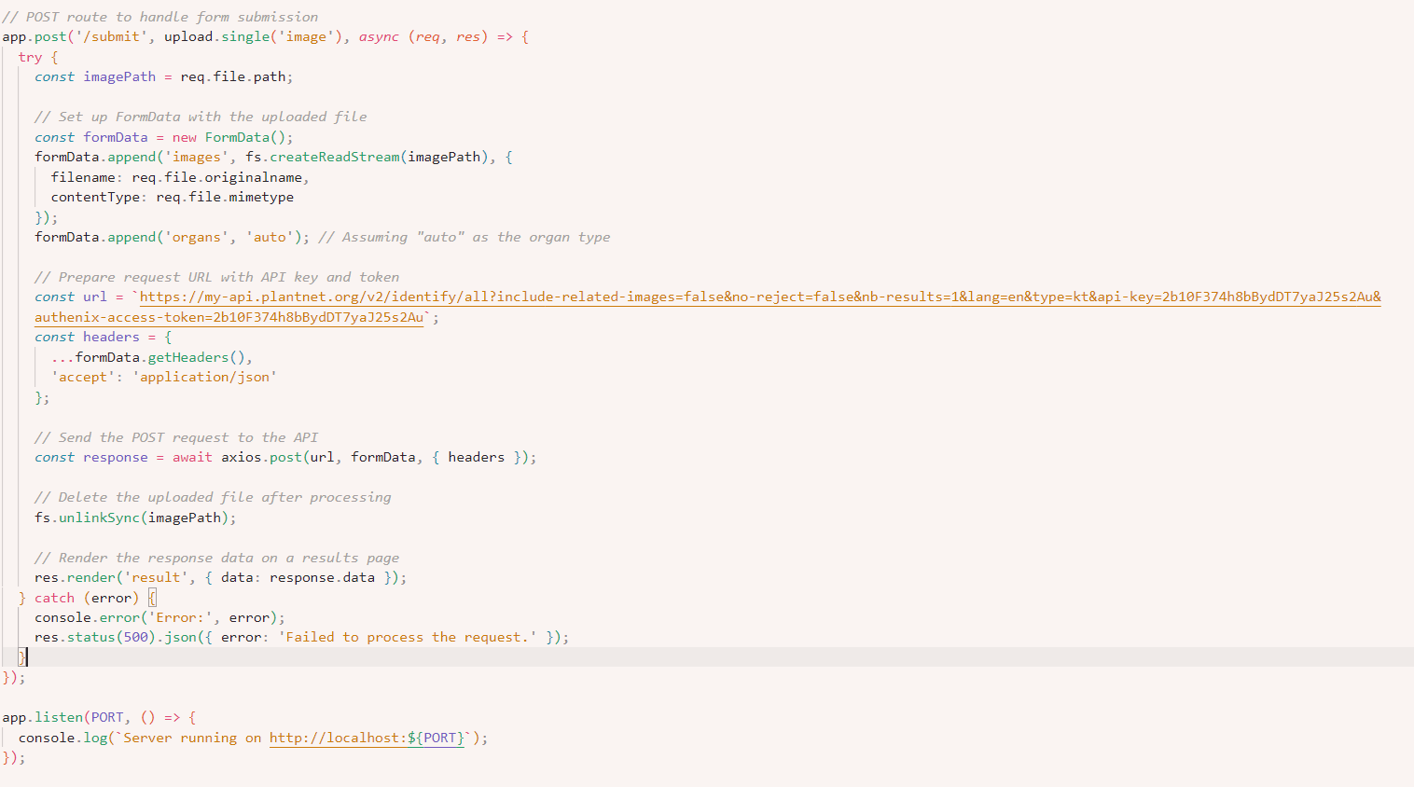

This code sets up a route for handling an image upload to identify a plant. Here’s a simplified explanation of what it does:

1. **Route Setup**:
   * The route listens for a POST request on the /submit path, where users will upload an image for plant identification.
2. **Handle the Uploaded Image**:
   * The uploaded image file is saved temporarily, and its path is captured.
3. **Prepare Image Data for API**:
   * The image file is then wrapped in a format that’s needed for the external plant identification API.
   * The form data includes the image and some additional information to specify that the plant organ should be auto-detected.
4. **Set Up and Send API Request**:
   * The route prepares the request, including an API key and other required data, and sends it to an external plant identification service using a URL specific to the service.
5. **Process and Cleanup**:
   * After the image is analyzed, the temporary file is deleted to save storage space.
   * The server then takes the response data (which includes details like the plant’s name and score) and displays it on a results page for the user.
6. **Error Handling**:
   * If there’s an issue in processing or getting a response from the API, an error message is logged and displayed to the user.
7. **Future Scope and Conclusion**

**Future Scope**

**1. Enhanced AI Accuracy and Model Training** The project currently relies on external APIs for plant identification, but a natural progression would be to integrate a custom machine learning model trained on a local database of regional flora. By gathering a diverse dataset of plants, this model could improve accuracy in identifying plant species relevant to specific geographies. Continuous model updates and fine-tuning based on user feedback can improve recognition rates and adapt to newly discovered species. In the long term, this can evolve into a leading resource for regional plant identification.

**2. Offline Capabilities and Data Storage Improvements** To support remote users, integrating offline capabilities through IndexedDB or local storage mechanisms could allow basic functionalities without internet connectivity. Users could identify plants and save data offline, synchronizing their information once reconnected. Future upgrades could also store data locally about previously identified plants, allowing users to view past results offline. Developing efficient data compression algorithms would make these offline features smoother without overburdening user devices.

**3. User Engagement and Community Features** A valuable addition to the platform would be community-driven features, such as a user forum or plant identification challenges. Users could participate in “Spot This Plant” challenges, share discoveries, and even contribute new images to a shared dataset. Incorporating gamification elements, like achievement badges or leaderboards, can further boost user engagement. These features would not only increase user retention but also provide valuable data that can be used to improve the machine learning model.

**4. Expanded Plant Knowledge Database** As the platform grows, creating an internal, comprehensive plant knowledge database that contains not only plant names but also information on their uses, growing conditions, medicinal properties, and potential hazards would enhance user experience. Collaborating with experts in botany and ecology can make this resource scientifically accurate. Additionally, enabling data imports from reputable databases like USDA or GBIF would make this platform a go-to for plant knowledge.

**5. Integration with IoT and Environmental Sensors** The future scope of this project includes integrating with IoT devices and environmental sensors to collect data directly from the user's environment, such as humidity, soil pH, or temperature. Such real-time data collection can improve the accuracy of plant recommendations by identifying species best suited for the current environment. This approach also aligns with precision agriculture trends, potentially aiding farmers and gardeners in optimizing their practices.

**6. Support for Multiple Language Models and Regional Content** Language support is critical for accessibility, especially in diverse regions with varying linguistic preferences. Future updates could include multilingual support, allowing more users to benefit from the platform in their native language. Additionally, offering region-specific information (for example, details on plants native to a user's region) could help make the app a valuable resource in ecological conservation efforts and education.

**7. Educational Features and Partnerships with Institutions** Incorporating educational tools, such as plant care tutorials, conservation tips, and quizzes, could make the app useful for educational institutions. Partnering with schools, colleges, or botanical organizations would allow for the sharing of data, research opportunities, and collaborative projects. These partnerships could also lead to user-driven data contributions, providing researchers with valuable insights into biodiversity and user engagement.

**8. Expanded Functionality with Augmented Reality (AR)** An augmented reality (AR) integration could greatly enhance the user experience, allowing users to view plant data overlaid directly onto the environment around them. This feature could help users better understand their surroundings by offering a virtual botanical guide. AR could also assist in educational scenarios, providing a hands-on learning tool in natural science courses or eco-walk tours.

**9. Health and Wellness Integration** Future updates can provide recommendations on the health benefits and potential medicinal uses of identified plants, which could attract a user base interested in natural health. Integration with health and wellness apps can make this project relevant in personal health management. For example, if a plant is known for medicinal properties that aid in stress relief or wound healing, these details could be shared with users, contributing to holistic wellness.

**10. Sustainable Development and Conservation Initiatives** As the application matures, it could contribute significantly to conservation efforts. Partnering with environmental organizations or government bodies to track plant species data could assist in monitoring biodiversity and identifying at-risk species. This project could then align with larger conservation goals, offering data that contributes to sustainable development practices.

**Conclusion**

The Plant Identification Progressive Web Application represents a vital step forward in leveraging artificial intelligence to bridge the gap between modern technology and natural science. Through its unique combination of user-friendliness, accurate plant identification, and educational value, the project addresses key needs in environmental awareness and plant identification accessibility. Its immediate success demonstrates the potential for AI-driven tools to provide practical solutions in both urban and rural settings.

In a world increasingly aware of environmental sustainability and biodiversity, this platform offers users an accessible way to engage with and learn about the natural world. By providing users with instant access to plant information, the platform not only educates but fosters a sense of connection to nature, which is invaluable for promoting conservation and sustainable practices. Furthermore, the simplicity of its interface and the potential to expand into a PWA means that anyone with a device and an internet connection can access this wealth of botanical knowledge.

The platform’s impact is not only limited to plant identification; it also contributes to broader goals, such as supporting sustainable agriculture, raising awareness of biodiversity, and assisting in environmental education. By identifying plant species, farmers can make informed decisions about crop diversity, helping to avoid monocultures and maintain soil health. In urban settings, users can gain insights into local flora, aiding in the creation of green spaces that contribute to mental well-being and air quality.

From a technical perspective, this project serves as a demonstration of how artificial intelligence can be applied to solve everyday problems in a meaningful way. Utilizing image recognition to identify plants, the application represents the possibilities of AI within environmental conservation. By refining this model over time with user-generated data, the system will grow more robust and capable of recognizing an even wider range of species with greater accuracy.

Moreover, the app’s design as a PWA enhances its accessibility and usability, making it a highly versatile tool. PWAs offer the advantages of both web and native applications, including offline access, reduced loading times, and adaptability across devices. As user adoption increases, this application can evolve to incorporate the latest in AI and web development technology, setting the standard for future educational and environmental PWAs.

Through this project, we have witnessed the integration of technology and environmental science in a way that emphasizes practical applications and user engagement. By nurturing users' natural curiosity about the plant kingdom, the platform plays a significant role in fostering an appreciation for biodiversity. This aligns with global environmental objectives by promoting ecological knowledge and contributing to ongoing conservation efforts. As the platform expands its scope through community engagement, partnerships, and technological enhancements, it holds the potential to become a widely recognized tool in plant identification, environmental education, and even agriculture.

In conclusion, the Plant Identification Progressive Web Application not only solves a practical problem but also lays the groundwork for a larger movement towards digital environmental literacy. By harnessing the power of machine learning and progressive web applications, this project contributes to a future where knowledge of plant biodiversity is accessible to all. As it continues to evolve, the platform can empower users to make environmentally conscious choices, further emphasizing the interconnectedness of technology, knowledge, and nature.

1. **References**

* Plant Species Identification based on Plant Leaf Using Computer Vision and Machine Learning Techniques [*Surleen Kaur*](https://www.researchgate.net/profile/Surleen-Kaur-3?_tp=eyJjb250ZXh0Ijp7ImZpcnN0UGFnZSI6Il9kaXJlY3QiLCJwYWdlIjoicHVibGljYXRpb24ifX0)
* Identification of Plant Species by Deep Learning and Providing as A Mobile Application [*M. Fatih Adak*](https://www.researchgate.net/profile/M-Fatih-Adak?_tp=eyJjb250ZXh0Ijp7ImZpcnN0UGFnZSI6Il9kaXJlY3QiLCJwYWdlIjoicHVibGljYXRpb24ifX0)